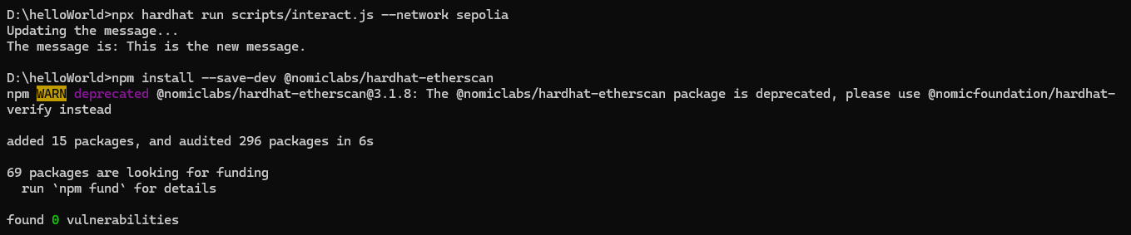

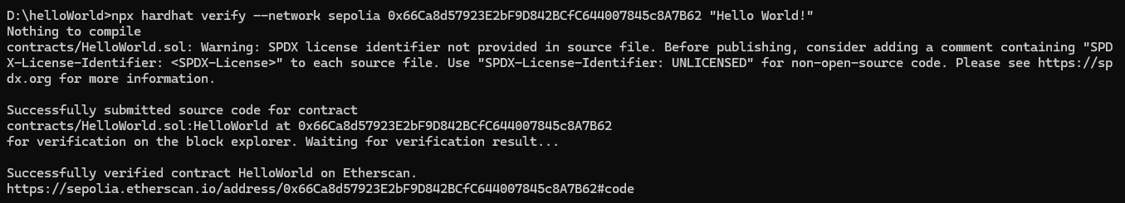

Github Link: <https://github.com/hanneka/2192-6BCHAIN-HRCP/tree/main/Smart%20Contract>

Reflection:

Submitting a smart contract to Etherscan is like showing your work to everyone. It's a big step for blockchain projects because it means your code is out there for anyone to see. It shows you're transparent and open to feedback. But it also means you need to be extra careful with your code to make sure it's safe. Once it's up there, you'll need to keep an eye on it and be ready to fix any issues. For investors, seeing your smart contract on Etherscan can help them trust your project more. Overall, it's a way to show you're serious about being honest and accountable in the blockchain world.